TATER TROT
Family 5K and 1 Mile Fun Run
7:30 a.m. October 10th
Gilmer High School
(850 Buffalo St.)

Sponsored by
Croley Funeral Home
The Credit Union of Texas
Cozy Coffee Station

Racheal Roberts, Chairman
(903) 841-0445
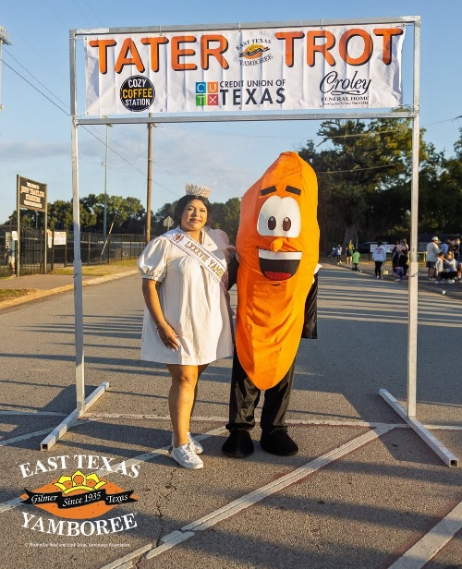

PRE-REGISTRATION FEE
Deadline September 25, 2026……………. $25.00
Family (maximum of 5) ……………………. $65.00

LATE REGISTRATION FEE
After September 25,2026..........................$30.00
Family (maximum of 5) …...………………. $80.00

AGE DIVISIONS for Men and Women

0-9, 10-14, 15-19, 20-29, 30-39, 40-49, 50-59, 60-69, 70+

Trophy for overall male and female finisher in the 5K. Ribbons will be given to the 1st and 2nd Place winners
in each age group, men and women.

A finisher’s medal will be given for Fun Run participants.

Participant T-shirts are guaranteed to all pre-registered runners, leftovers will be available on the day of the race, first come-first serve.

For race photos visit photobyruel.biz

One Water Station Drinks and Fruit at Finish
Course Marked Restrooms Available

